

Database Management Systems

CSC 220

Assignment 4,6 Report

Submitted to: **Sir Hassan Tanvir and Sir Sikandar Hayat**

Submitted by: **Mubeen Ahmed Jawad (01-134182-081)**

**Umair Ilyas (01-134182-108)**

Class: **BSCS 4-A**

Submission Date: **7th May, 2020**

Department of Computer Science

Bahria University Islamabad Campus

**Nescafe Basement DBMS Application**

This should be the final step of your challenging yet exciting Nescafe Basement DBMS Project. You have done remarkably well to get to this point. It is now time to bundle the individual bits that you have developed up till now into a useful C# application. You probably are familiar with a GUI application in C#, which is sufficient for this part of the homework. All you need to do is to develop a C# application that allows users to manipulate data and answer business question, i.e. generate reports.

Your application should have the following functionality:

1. Data Manipulation
   1. Insert Data (e.g. insert an artist, insert a record, insert a season, etc.)
   2. Update Data (e.g. update artist information, update record information, etc.)
   3. Delete Data (e.g. delete artist, delete season, delete record, etc.)

**Software used:**

* Microsoft Visual Studio 2019
* Microsoft SQL Management Studio 18
* Notepad

**Problems:**

* Had some connection issues in SQL Server which we managed to fix by using windows authentication mode.
* Making every single form and writing the code for them was quite time consuming.

**SQL Server to Visual Studio Connection:**

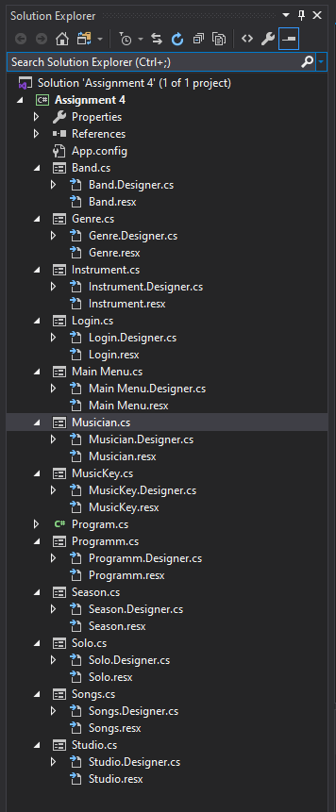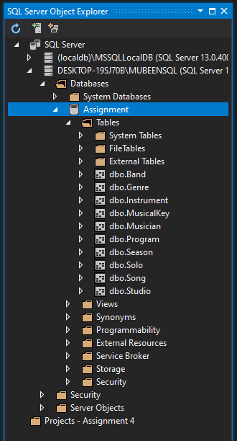

**GUI Forms with Coding:**

**Login Screen Form:**

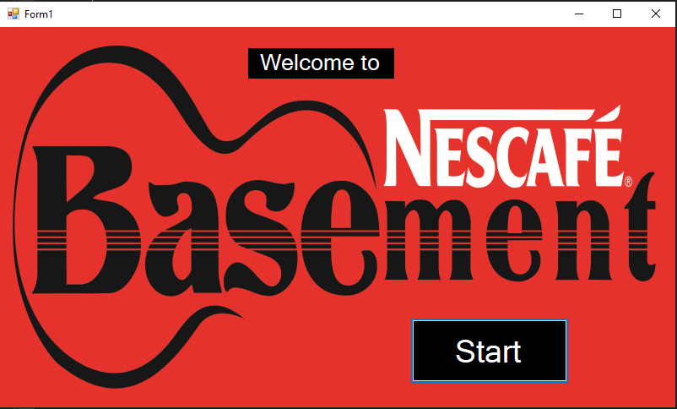

**Code:**

namespace Assignment_4

{

public partial class Form1 : Form

{

public Form1()

{

InitializeComponent();

}

private void button1_Click(object sender, EventArgs e)

{

Form2 f1 = new Form2();

f1.Show();

}

private void Form1_Load(object sender, EventArgs e)

{

}

}

}

**Main Menu Form:**

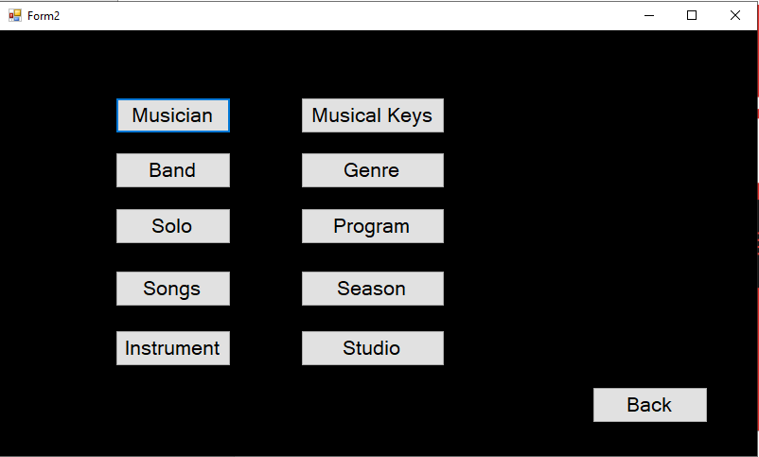

**Code:**

namespace Assignment_4

{

public partial class Form2 : Form

{

public Form2()

{

InitializeComponent();

}

private void button3_Click(object sender, EventArgs e)

{

Solo f1 = new Solo();

f1.Show();

}

private void button11_Click(object sender, EventArgs e)

{

Form1 f1 = new Form1();

f1.Show();

}

private void button1_Click(object sender, EventArgs e)

{

Musician f1 = new Musician();

f1.Show();

}

private void button2_Click(object sender, EventArgs e)

{

Band f1 = new Band();

f1.Show();

}

private void button4_Click(object sender, EventArgs e)

{

Songs f1 = new Songs();

f1.Show();

}

private void button5_Click(object sender, EventArgs e)

{

Instrument f1 = new Instrument();

f1.Show();

}

private void button6_Click(object sender, EventArgs e)

{

MusicKey f1 = new MusicKey();

f1.Show();

}

private void button7_Click(object sender, EventArgs e)

{

Genre f1 = new Genre();

f1.Show();

}

private void button8_Click(object sender, EventArgs e)

{

Programm f1 = new Programm();

f1.Show();

}

private void button9_Click(object sender, EventArgs e)

{

Season f1 = new Season();

f1.Show();

}

private void button10_Click(object sender, EventArgs e)

{

Studio f1 = new Studio();

f1.Show();

}

}

}

**Musician Form:**

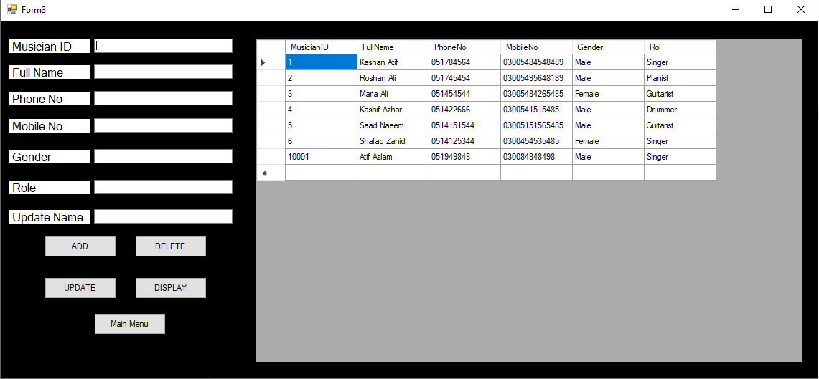

**Code:**

using System;

using System.Collections.Generic;

using System.ComponentModel;

using System.Data;

using System.Drawing;

using System.Linq;

using System.Text;

using System.Threading.Tasks;

using System.Windows.Forms;

using System.Data.SqlClient;

namespace Assignment_4

{

public partial class Musician : Form

{

SqlConnection con = new SqlConnection(@"Data Source=DESKTOP-19SJ70B\MUBEENSQL;Initial Catalog=Assignment;Integrated Security=True;Connect Timeout=30;Encrypt=False;TrustServerCertificate=False;ApplicationIntent=ReadWrite;MultiSubnetFailover=False");

public Musician()

{

InitializeComponent();

}

private void Musician_Load(object sender, EventArgs e)

{

display_data();

}

private void label3_Click(object sender, EventArgs e)

{

}

private void button5_Click(object sender, EventArgs e)

{

Form2 f1 = new Form2();

f1.Show();

}

private void button1_Click(object sender, EventArgs e)

{

con.Open();

SqlCommand cmd = con.CreateCommand();

cmd.CommandType = CommandType.Text;

cmd.CommandText = "Insert into [Musician] values('"+textBox1.Text+"', '"+textBox2.Text+"', '"+textBox3.Text+"', '"+textBox4.Text+"', '"+textBox5.Text+"', '"+textBox6.Text+"')";

cmd.ExecuteNonQuery();

con.Close();

display_data();

MessageBox.Show("Record Inserted!");

}

public void display_data()

{

con.Open();

SqlCommand cmd = con.CreateCommand();

cmd.CommandType = CommandType.Text;

cmd.CommandText = "select * from [Musician]";

cmd.ExecuteNonQuery();

DataTable dt = new DataTable();

SqlDataAdapter da = new SqlDataAdapter(cmd);

da.Fill(dt);

dataGridView1.DataSource = dt;

con.Close();

}

private void button2_Click(object sender, EventArgs e)

{

con.Open();

SqlCommand cmd = con.CreateCommand();

cmd.CommandType = CommandType.Text;

cmd.CommandText = "delete from [Musician] where FullName= '" + textBox2.Text + "'";

cmd.ExecuteNonQuery();

con.Close();

display_data();

MessageBox.Show("Record Deleted!");

}

private void button3_Click(object sender, EventArgs e)

{

con.Open();

SqlCommand cmd = con.CreateCommand();

cmd.CommandType = CommandType.Text;

cmd.CommandText = "update [Musician] set FullName='"+textBox7.Text+"' where FullName= '" +textBox2.Text+ "'";

cmd.ExecuteNonQuery();

con.Close();

display_data();

MessageBox.Show("Record Updated!");

}

private void button4_Click(object sender, EventArgs e)

{

display_data();

}

}

}

**Band Form:**

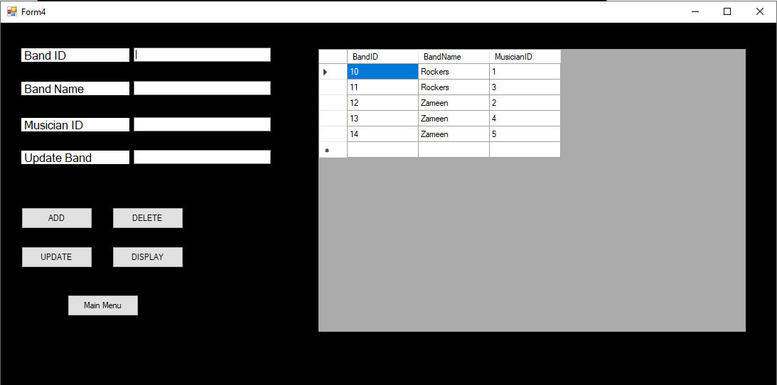

**Code:**

namespace Assignment_4

{

public partial class Band : Form

{

SqlConnection con = new SqlConnection(@"Data Source=DESKTOP-19SJ70B\MUBEENSQL;Initial Catalog=Assignment;Integrated Security=True;Connect Timeout=30;Encrypt=False;TrustServerCertificate=False;ApplicationIntent=ReadWrite;MultiSubnetFailover=False");

public Band()

{

InitializeComponent();

}

private void button5_Click(object sender, EventArgs e)

{

Form2 f1 = new Form2();

f1.Show();

}

private void Band_Load(object sender, EventArgs e)

{

display_data();

}

private void button1_Click(object sender, EventArgs e)

{

con.Open();

SqlCommand cmd = con.CreateCommand();

cmd.CommandType = CommandType.Text;

cmd.CommandText = "Insert into [Band] values('" + textBox1.Text + "', '" + textBox2.Text + "', '" + textBox3.Text + "')";

cmd.ExecuteNonQuery();

con.Close();

display_data();

MessageBox.Show("Record Inserted!");

}

public void display_data()

{

con.Open();

SqlCommand cmd = con.CreateCommand();

cmd.CommandType = CommandType.Text;

cmd.CommandText = "select * from [Band]";

cmd.ExecuteNonQuery();

DataTable dt = new DataTable();

SqlDataAdapter da = new SqlDataAdapter(cmd);

da.Fill(dt);

dataGridView1.DataSource = dt;

con.Close();

}

private void button2_Click(object sender, EventArgs e)

{

con.Open();

SqlCommand cmd = con.CreateCommand();

cmd.CommandType = CommandType.Text;

cmd.CommandText = "delete from [Band] where BandName= '" + textBox2.Text + "'";

cmd.ExecuteNonQuery();

con.Close();

display_data();

MessageBox.Show("Record Deleted!");

}

private void button3_Click(object sender, EventArgs e)

{

con.Open();

SqlCommand cmd = con.CreateCommand();

cmd.CommandType = CommandType.Text;

cmd.CommandText = "update [Band] set BandName='" + textBox4.Text + "' where BandName= '" + textBox2.Text + "'";

cmd.ExecuteNonQuery();

con.Close();

display_data();

MessageBox.Show("Record Updated!");

}

private void button4_Click(object sender, EventArgs e)

{

display_data();

}

}

}

**Solo Form:**

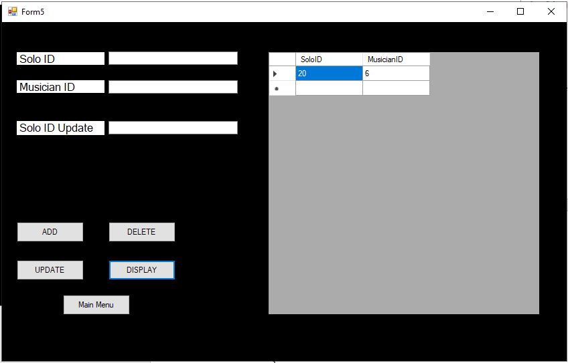

**Code:**

namespace Assignment_4

{

public partial class Solo : Form

{

SqlConnection con = new SqlConnection(@"Data Source=DESKTOP-19SJ70B\MUBEENSQL;Initial Catalog=Assignment;Integrated Security=True;Connect Timeout=30;Encrypt=False;TrustServerCertificate=False;ApplicationIntent=ReadWrite;MultiSubnetFailover=False");

public Solo()

{

InitializeComponent();

}

private void Solo_Load(object sender, EventArgs e)

{

display_data();

}

private void button2_Click(object sender, EventArgs e)

{

con.Open();

SqlCommand cmd = con.CreateCommand();

cmd.CommandType = CommandType.Text;

cmd.CommandText = "delete from [Solo] where SoloID= '" + textBox1.Text + "'";

cmd.ExecuteNonQuery();

con.Close();

display_data();

MessageBox.Show("Record Deleted!");

}

private void button5_Click(object sender, EventArgs e)

{

Form2 f1 = new Form2();

f1.Show();

}

private void button1_Click(object sender, EventArgs e)

{

con.Open();

SqlCommand cmd = con.CreateCommand();

cmd.CommandType = CommandType.Text;

cmd.CommandText = "Insert into [Solo] values('" + textBox1.Text + "', '" + textBox2.Text + "')";

cmd.ExecuteNonQuery();

con.Close();

display_data();

MessageBox.Show("Record Inserted!");

}

public void display_data()

{

con.Open();

SqlCommand cmd = con.CreateCommand();

cmd.CommandType = CommandType.Text;

cmd.CommandText = "select * from [Solo]";

cmd.ExecuteNonQuery();

DataTable dt = new DataTable();

SqlDataAdapter da = new SqlDataAdapter(cmd);

da.Fill(dt);

dataGridView1.DataSource = dt;

con.Close();

}

private void button3_Click(object sender, EventArgs e)

{

con.Open();

SqlCommand cmd = con.CreateCommand();

cmd.CommandType = CommandType.Text;

cmd.CommandText = "update [Solo] set SoloID='" + textBox3.Text + "' where SoloID= '" + textBox2.Text + "'";

cmd.ExecuteNonQuery();

con.Close();

display_data();

MessageBox.Show("Record Updated!");

}

private void button4_Click(object sender, EventArgs e)

{

display_data();

}

}

}

**Song Form:**

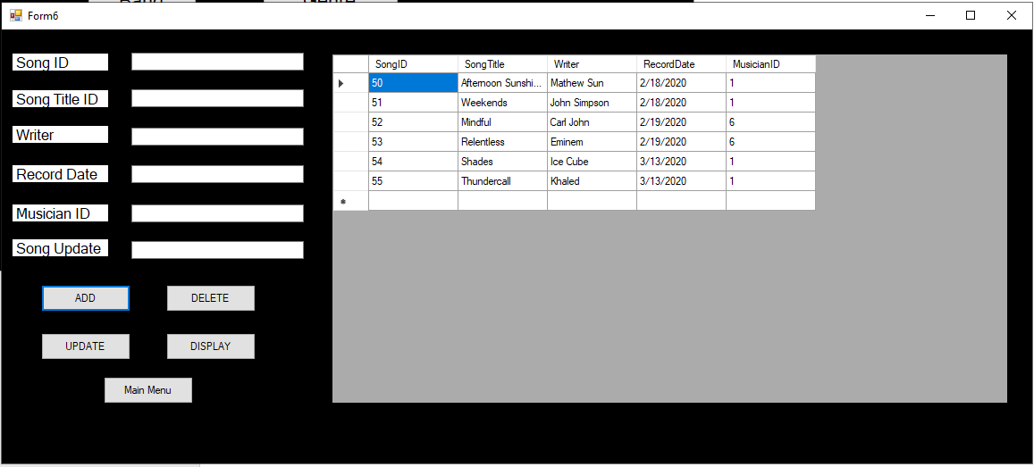

**Code:**

namespace Assignment_4

{

public partial class Songs : Form

{

SqlConnection con = new SqlConnection(@"Data Source=DESKTOP-19SJ70B\MUBEENSQL;Initial Catalog=Assignment;Integrated Security=True;Connect Timeout=30;Encrypt=False;TrustServerCertificate=False;ApplicationIntent=ReadWrite;MultiSubnetFailover=False");

public Songs()

{

InitializeComponent();

}

private void button2_Click(object sender, EventArgs e)

{

Form2 f1 = new Form2();

f1.Show();

}

private void Songs_Load(object sender, EventArgs e)

{

display_data();

}

private void button5_Click(object sender, EventArgs e)

{

con.Open();

SqlCommand cmd = con.CreateCommand();

cmd.CommandType = CommandType.Text;

cmd.CommandText = "Insert into [Song] values('" + textBox1.Text + "', '" + textBox2.Text + "', '" + textBox3.Text + "', '" + textBox4.Text + "', '" + textBox5.Text + "')";

cmd.ExecuteNonQuery();

con.Close();

display_data();

MessageBox.Show("Record Inserted!");

}

public void display_data()

{

con.Open();

SqlCommand cmd = con.CreateCommand();

cmd.CommandType = CommandType.Text;

cmd.CommandText = "select * from [Song]";

cmd.ExecuteNonQuery();

DataTable dt = new DataTable();

SqlDataAdapter da = new SqlDataAdapter(cmd);

da.Fill(dt);

dataGridView1.DataSource = dt;

con.Close();

}

private void button1_Click(object sender, EventArgs e)

{

con.Open();

SqlCommand cmd = con.CreateCommand();

cmd.CommandType = CommandType.Text;

cmd.CommandText = "delete from [Song] where SongTitle= '" + textBox2.Text + "'";

cmd.ExecuteNonQuery();

con.Close();

display_data();

MessageBox.Show("Record Deleted!");

}

private void button4_Click(object sender, EventArgs e)

{

con.Open();

SqlCommand cmd = con.CreateCommand();

cmd.CommandType = CommandType.Text;

cmd.CommandText = "update [Song] set SongTitile='" + textBox6.Text + "' where SongTitle= '" + textBox2.Text + "'";

cmd.ExecuteNonQuery();

con.Close();

display_data();

MessageBox.Show("Record Updated!");

}

private void button3_Click(object sender, EventArgs e)

{

display_data();

}

}

}

**Instrument Form:**

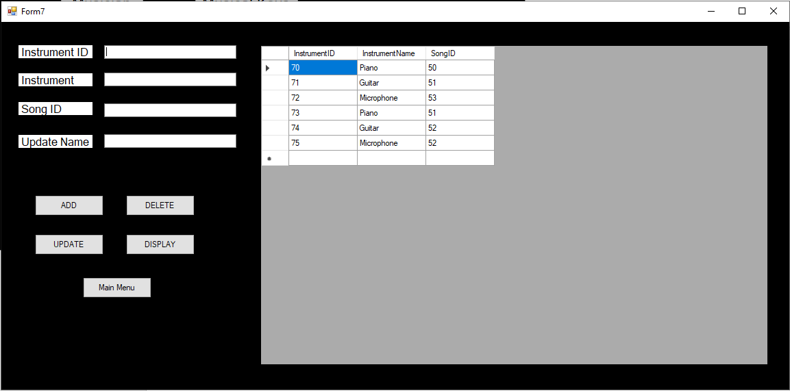

**Code:**

namespace Assignment_4

{

public partial class Instrument : Form

{

SqlConnection con = new SqlConnection(@"Data Source=DESKTOP-19SJ70B\MUBEENSQL;Initial Catalog=Assignment;Integrated Security=True;Connect Timeout=30;Encrypt=False;TrustServerCertificate=False;ApplicationIntent=ReadWrite;MultiSubnetFailover=False");

public Instrument()

{

InitializeComponent();

}

private void button4_Click(object sender, EventArgs e)

{

Form2 f1 = new Form2();

f1.Show();

}

private void Instrument_Load(object sender, EventArgs e)

{

display_data();

}

private void button5_Click(object sender, EventArgs e)

{

con.Open();

SqlCommand cmd = con.CreateCommand();

cmd.CommandType = CommandType.Text;

cmd.CommandText = "Insert into [Instrument] values('" + textBox1.Text + "', '" + textBox2.Text + "', '" + textBox3.Text + "')";

cmd.ExecuteNonQuery();

con.Close();

display_data();

MessageBox.Show("Record Inserted!");

}

public void display_data()

{

con.Open();

SqlCommand cmd = con.CreateCommand();

cmd.CommandType = CommandType.Text;

cmd.CommandText = "select * from [Instrument]";

cmd.ExecuteNonQuery();

DataTable dt = new DataTable();

SqlDataAdapter da = new SqlDataAdapter(cmd);

da.Fill(dt);

dataGridView1.DataSource = dt;

con.Close();

}

private void button1_Click(object sender, EventArgs e)

{

con.Open();

SqlCommand cmd = con.CreateCommand();

cmd.CommandType = CommandType.Text;

cmd.CommandText = "delete from [Insturment] where InstrumentName= '" + textBox2.Text + "'";

cmd.ExecuteNonQuery();

con.Close();

display_data();

MessageBox.Show("Record Deleted!");

}

private void button2_Click(object sender, EventArgs e)

{

con.Open();

SqlCommand cmd = con.CreateCommand();

cmd.CommandType = CommandType.Text;

cmd.CommandText = "update [Instrument] set InstrumentName='" + textBox4.Text + "' where InstrumentName= '" + textBox2.Text + "'";

cmd.ExecuteNonQuery();

con.Close();

display_data();

MessageBox.Show("Record Updated!");

}

private void button3_Click(object sender, EventArgs e)

{

display_data();

}

}

}

**Musical Key Form:**

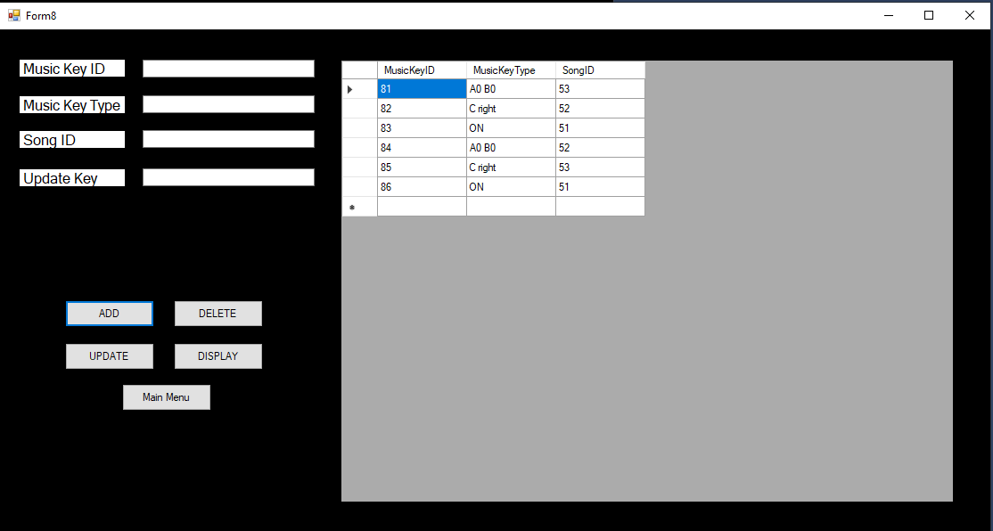

**Code:**

namespace Assignment_4

{

public partial class MusicKey : Form

{

SqlConnection con = new SqlConnection(@"Data Source=DESKTOP-19SJ70B\MUBEENSQL;Initial Catalog=Assignment;Integrated Security=True;Connect Timeout=30;Encrypt=False;TrustServerCertificate=False;ApplicationIntent=ReadWrite;MultiSubnetFailover=False");

public MusicKey()

{

InitializeComponent();

}

private void button4_Click(object sender, EventArgs e)

{

Form2 f1 = new Form2();

f1.Show();

}

private void MusicKey_Load(object sender, EventArgs e)

{

display_data();

}

private void button5_Click(object sender, EventArgs e)

{

con.Open();

SqlCommand cmd = con.CreateCommand();

cmd.CommandType = CommandType.Text;

cmd.CommandText = "Insert into [MusicalKey] values('" + textBox1.Text + "', '" + textBox2.Text + "', '" + textBox3.Text + "')";

cmd.ExecuteNonQuery();

con.Close();

display_data();

MessageBox.Show("Record Inserted!");

}

public void display_data()

{

con.Open();

SqlCommand cmd = con.CreateCommand();

cmd.CommandType = CommandType.Text;

cmd.CommandText = "select * from [MusicalKey]";

cmd.ExecuteNonQuery();

DataTable dt = new DataTable();

SqlDataAdapter da = new SqlDataAdapter(cmd);

da.Fill(dt);

dataGridView1.DataSource = dt;

con.Close();

}

private void button1_Click(object sender, EventArgs e)

{

con.Open();

SqlCommand cmd = con.CreateCommand();

cmd.CommandType = CommandType.Text;

cmd.CommandText = "delete from [MusicalKey] where MusicKeyType= '" + textBox2.Text + "'";

cmd.ExecuteNonQuery();

con.Close();

display_data();

MessageBox.Show("Record Deleted!");

}

private void button2_Click(object sender, EventArgs e)

{

con.Open();

SqlCommand cmd = con.CreateCommand();

cmd.CommandType = CommandType.Text;

cmd.CommandText = "update [MusicalKey] set MusicKeyType='" + textBox4.Text + "' where MusicKeyType= '" + textBox2.Text + "'";

cmd.ExecuteNonQuery();

con.Close();

display_data();

MessageBox.Show("Record Updated!");

}

private void button3_Click(object sender, EventArgs e)

{

display_data();

}

}

}

**Genre Form:**

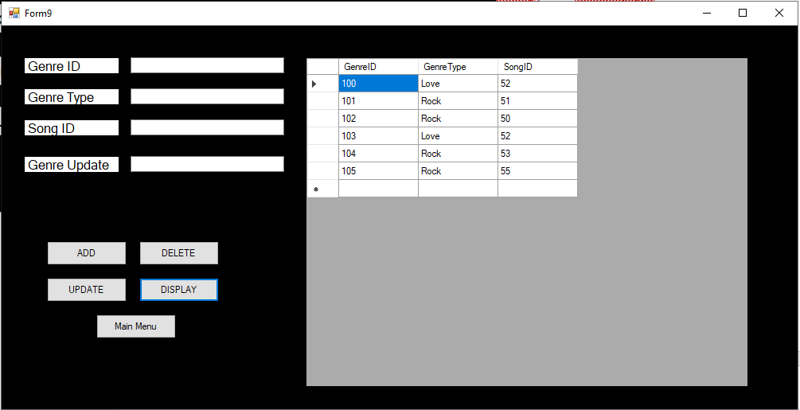

**Code:**

namespace Assignment_4

{

public partial class Genre : Form

{

SqlConnection con = new SqlConnection(@"Data Source=DESKTOP-19SJ70B\MUBEENSQL;Initial Catalog=Assignment;Integrated Security=True;Connect Timeout=30;Encrypt=False;TrustServerCertificate=False;ApplicationIntent=ReadWrite;MultiSubnetFailover=False");

public Genre()

{

InitializeComponent();

}

private void button4_Click(object sender, EventArgs e)

{

Form2 f1 = new Form2();

f1.Show();

}

private void Genre_Load(object sender, EventArgs e)

{

display_data();

}

private void button5_Click(object sender, EventArgs e)

{

con.Open();

SqlCommand cmd = con.CreateCommand();

cmd.CommandType = CommandType.Text;

cmd.CommandText = "Insert into [Genre] values('" + textBox1.Text + "', '" + textBox2.Text + "', '" + textBox3.Text + "')";

cmd.ExecuteNonQuery();

con.Close();

display_data();

MessageBox.Show("Record Inserted!");

}

public void display_data()

{

con.Open();

SqlCommand cmd = con.CreateCommand();

cmd.CommandType = CommandType.Text;

cmd.CommandText = "select * from [Genre]";

cmd.ExecuteNonQuery();

DataTable dt = new DataTable();

SqlDataAdapter da = new SqlDataAdapter(cmd);

da.Fill(dt);

dataGridView1.DataSource = dt;

con.Close();

}

private void button1_Click(object sender, EventArgs e)

{

con.Open();

SqlCommand cmd = con.CreateCommand();

cmd.CommandType = CommandType.Text;

cmd.CommandText = "delete from [Genre] where GenreType= '" + textBox2.Text + "'";

cmd.ExecuteNonQuery();

con.Close();

display_data();

MessageBox.Show("Record Deleted!");

}

private void button2_Click(object sender, EventArgs e)

{

con.Open();

SqlCommand cmd = con.CreateCommand();

cmd.CommandType = CommandType.Text;

cmd.CommandText = "update [Genre] set GenreType='" + textBox4.Text + "' where GenreType= '" + textBox2.Text + "'";

cmd.ExecuteNonQuery();

con.Close();

display_data();

MessageBox.Show("Record Updated!");

}

private void button3_Click(object sender, EventArgs e)

{

display_data();

}

}

}

**Program Form:**

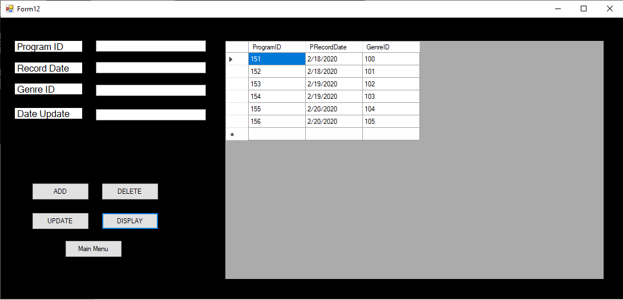

**Code:**

namespace Assignment_4

{

public partial class Programm : Form

{

SqlConnection con = new SqlConnection(@"Data Source=DESKTOP-19SJ70B\MUBEENSQL;Initial Catalog=Assignment;Integrated Security=True;Connect Timeout=30;Encrypt=False;TrustServerCertificate=False;ApplicationIntent=ReadWrite;MultiSubnetFailover=False");

public Programm()

{

InitializeComponent();

}

private void button4_Click(object sender, EventArgs e)

{

Form2 f1 = new Form2();

f1.Show();

}

private void Programm_Load(object sender, EventArgs e)

{

display_data();

}

private void button5_Click(object sender, EventArgs e)

{

con.Open();

SqlCommand cmd = con.CreateCommand();

cmd.CommandType = CommandType.Text;

cmd.CommandText = "Insert into [Program] values('" + textBox1.Text + "', '" + textBox2.Text + "', '" + textBox3.Text + "')";

cmd.ExecuteNonQuery();

con.Close();

display_data();

MessageBox.Show("Record Inserted!");

}

public void display_data()

{

con.Open();

SqlCommand cmd = con.CreateCommand();

cmd.CommandType = CommandType.Text;

cmd.CommandText = "select * from [Program]";

cmd.ExecuteNonQuery();

DataTable dt = new DataTable();

SqlDataAdapter da = new SqlDataAdapter(cmd);

da.Fill(dt);

dataGridView1.DataSource = dt;

con.Close();

}

private void button1_Click(object sender, EventArgs e)

{

con.Open();

SqlCommand cmd = con.CreateCommand();

cmd.CommandType = CommandType.Text;

cmd.CommandText = "delete from [Program] where PRecordDate= '" + textBox2.Text + "'";

cmd.ExecuteNonQuery();

con.Close();

display_data();

MessageBox.Show("Record Deleted!");

}

private void button2_Click(object sender, EventArgs e)

{

con.Open();

SqlCommand cmd = con.CreateCommand();

cmd.CommandType = CommandType.Text;

cmd.CommandText = "update [Program] set PRecordDate='" + textBox4.Text + "' where PRecordDate= '" + textBox2.Text + "'";

cmd.ExecuteNonQuery();

con.Close();

display_data();

MessageBox.Show("Record Updated!");

}

private void button3_Click(object sender, EventArgs e)

{

display_data();

}

}

}

**Season Form:**

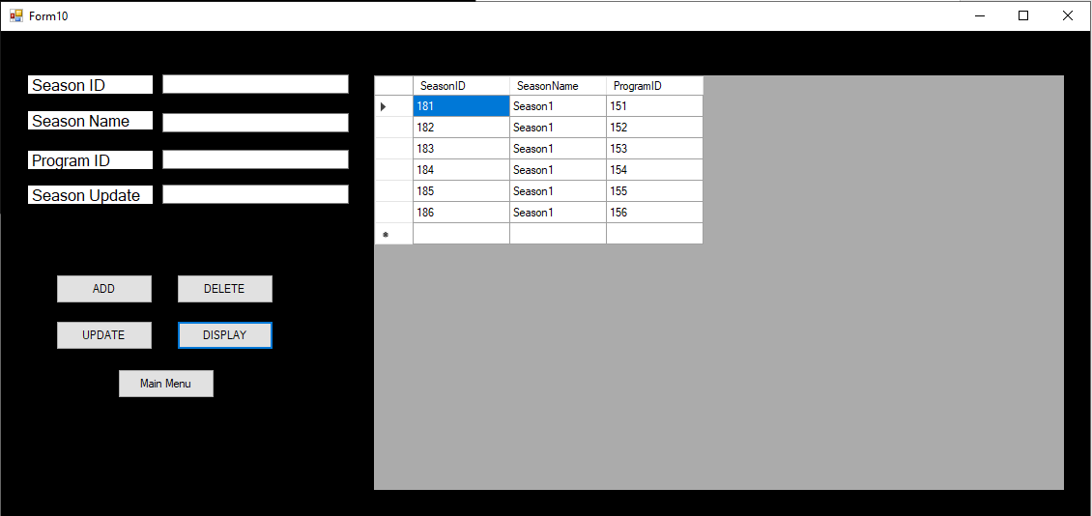

**Code:**

namespace Assignment_4

{

public partial class Season : Form

{

SqlConnection con = new SqlConnection(@"Data Source=DESKTOP-19SJ70B\MUBEENSQL;Initial Catalog=Assignment;Integrated Security=True;Connect Timeout=30;Encrypt=False;TrustServerCertificate=False;ApplicationIntent=ReadWrite;MultiSubnetFailover=False");

public Season()

{

InitializeComponent();

}

private void button5_Click(object sender, EventArgs e)

{

Form2 f1 = new Form2();

f1.Show();

}

private void Season_Load(object sender, EventArgs e)

{

display_data();

}

private void button1_Click(object sender, EventArgs e)

{

con.Open();

SqlCommand cmd = con.CreateCommand();

cmd.CommandType = CommandType.Text;

cmd.CommandText = "Insert into [Season] values('" + textBox1.Text + "', '" + textBox2.Text + "', '" + textBox3.Text + "')";

cmd.ExecuteNonQuery();

con.Close();

display_data();

MessageBox.Show("Record Inserted!");

}

public void display_data()

{

con.Open();

SqlCommand cmd = con.CreateCommand();

cmd.CommandType = CommandType.Text;

cmd.CommandText = "select * from [Season]";

cmd.ExecuteNonQuery();

DataTable dt = new DataTable();

SqlDataAdapter da = new SqlDataAdapter(cmd);

da.Fill(dt);

dataGridView1.DataSource = dt;

con.Close();

}

private void button2_Click(object sender, EventArgs e)

{

con.Open();

SqlCommand cmd = con.CreateCommand();

cmd.CommandType = CommandType.Text;

cmd.CommandText = "delete from [Season] where SeasonName= '" + textBox2.Text + "'";

cmd.ExecuteNonQuery();

con.Close();

display_data();

MessageBox.Show("Record Deleted!");

}

private void button3_Click(object sender, EventArgs e)

{

con.Open();

SqlCommand cmd = con.CreateCommand();

cmd.CommandType = CommandType.Text;

cmd.CommandText = "update [Season] set SeasonName='" + textBox4.Text + "' where SeasonName= '" + textBox2.Text + "'";

cmd.ExecuteNonQuery();

con.Close();

display_data();

MessageBox.Show("Record Updated!");

}

private void button4_Click(object sender, EventArgs e)

{

display_data();

}

}

}

**Studio Form:**

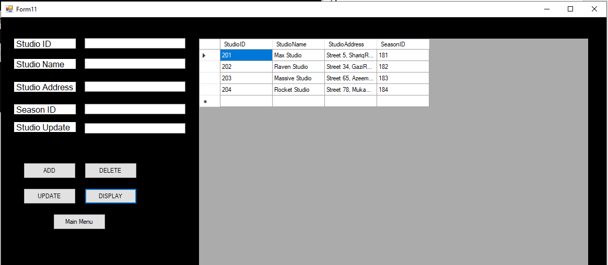

**Code:**

namespace Assignment_4

{

public partial class Studio : Form

{

SqlConnection con = new SqlConnection(@"Data Source=DESKTOP-19SJ70B\MUBEENSQL;Initial Catalog=Assignment;Integrated Security=True;Connect Timeout=30;Encrypt=False;TrustServerCertificate=False;ApplicationIntent=ReadWrite;MultiSubnetFailover=False");

public Studio()

{

InitializeComponent();

}

private void button5_Click(object sender, EventArgs e)

{

Form2 f1 = new Form2();

f1.Show();

}

private void Studio_Load(object sender, EventArgs e)

{

display_data();

}

private void button1_Click(object sender, EventArgs e)

{

con.Open();

SqlCommand cmd = con.CreateCommand();

cmd.CommandType = CommandType.Text;

cmd.CommandText = "Insert into [Studio] values('" + textBox1.Text + "', '" + textBox2.Text + "', '" + textBox3.Text + "', '" + textBox4.Text + "')";

cmd.ExecuteNonQuery();

con.Close();

display_data();

MessageBox.Show("Record Inserted!");

}

public void display_data()

{

con.Open();

SqlCommand cmd = con.CreateCommand();

cmd.CommandType = CommandType.Text;

cmd.CommandText = "select * from [Studio]";

cmd.ExecuteNonQuery();

DataTable dt = new DataTable();

SqlDataAdapter da = new SqlDataAdapter(cmd);

da.Fill(dt);

dataGridView1.DataSource = dt;

con.Close();

}

private void button2_Click(object sender, EventArgs e)

{

con.Open();

SqlCommand cmd = con.CreateCommand();

cmd.CommandType = CommandType.Text;

cmd.CommandText = "delete from [Studio] where StudioName= '" + textBox2.Text + "'";

cmd.ExecuteNonQuery();

con.Close();

display_data();

MessageBox.Show("Record Deleted!");

}

private void button3_Click(object sender, EventArgs e)

{

con.Open();

SqlCommand cmd = con.CreateCommand();

cmd.CommandType = CommandType.Text;

cmd.CommandText = "update [Studio] set StudioName='" + textBox5.Text + "' where StudioName= '" + textBox2.Text + "'";

cmd.ExecuteNonQuery();

con.Close();

display_data();

MessageBox.Show("Record Updated!");

}

private void button4_Click(object sender, EventArgs e)

{

display_data();

}

}

}

*****************************************************